V & A Tapestries – three questions
The Triumph of Death and The Triumph of Eternity

Two adjacent tapestries located in a corner of Room 94 have The Three Fates as a common theme.

- In the Triumph of Death (below right) the main content comprises The Three Fates with their “victim” being the personification of Chastity.

- Alongside is The Triumph of Eternity (left below) represented by a victor’s chariot crushing bodies labelled as Clotho and Lachesis.

From the two tapestries Death can be seen to be overcome by Eternity.

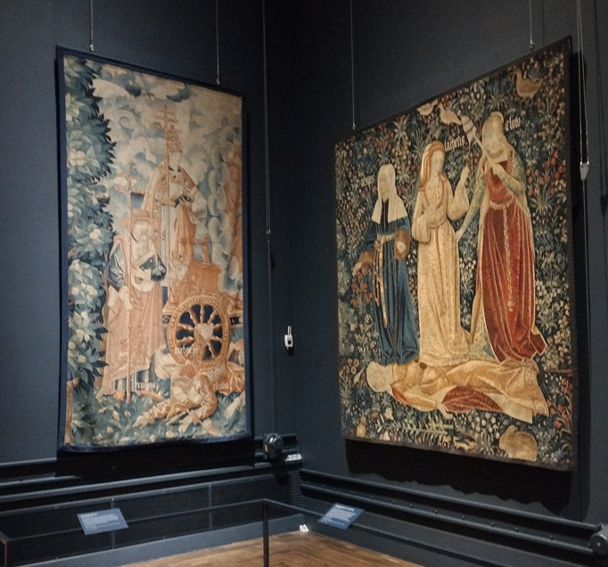
The Triumph of Death tapestry
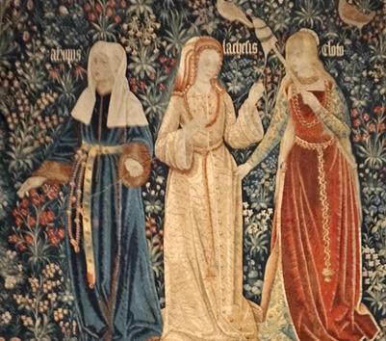
The Three Fates
Clota / Clotho span the thread of life ≡ future.

Lachesis measured its length (the allotter) ≡ present.

Atropos cut it, bringing its inevitable end ≡ past.

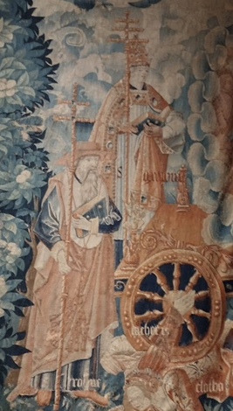
The Triumph of Eternity tapestry

Saint Augustine - carrying a patriarchal Cross.

Saint Jerome - carrying a patriarchal Cross.

Chariot of Eternity

Lachesis

Clotho

Another hand

In Greek religion and mythology the Three Fates were known as The Moirai (as they were in previous and later related beliefs) and, significantly, represented Destiny more than just Death. Their tasks of spinning the thread of life, measuring its length and bringing its inevitable end can be interpreted as future, present and past.

Three questions:

- Whilst the Three Fates clearly provide a connection between these tapestries, the inclusion of two Saints on the Triumph of Eternity is unclear. Considering the time period when this tapestry was woven this prompts the question - why are Greek religion / mythology items overlaid with Christian ones?

- Additionally, is there a significance in having Saint Augustine and Saint Jerome (who were two of the four great fathers of the western church)?

- Considering their prospective source, the sides of these two V&A tapestries are trimmed rather than bordered. Those in the Hampton Court collection have borders – one fully bordered and three bordered on three sides each. It appears that the V&A examples are not cut down from the Hampton Court items. Nor are they from the Chateau de Chaumont set. So, finally, what is the source of these tapestries?

Information sources include:

Clotho - Wikipedia
Lachesis - Wikipedia
Atropos - Wikipedia

The Triumph of Eternity (From Chateau de Chaumont Set) : Free Download, Borrow, and Streaming : Internet Archive

The Triumph of Eternity over Time | Unknown | V&A Explore The Collections (vam.ac.uk)

Chateau de Chaumont Set : Free Download, Borrow, and Streaming : Internet Archive

Flemish - The Triumphs of Petrarch (rct.uk)

Questions posed to V&A in May 2024 by Norman J Penny
Email normanjpenny@gmail.com

